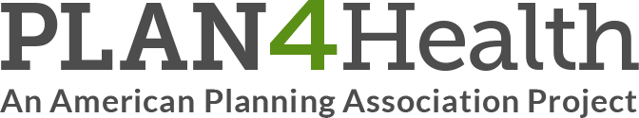
Round Table event evaluation June 20, 2017
- What role do you most commonly play in advancing planning and health within your community?
- Planner
- Public Health
- Community member
- Other ________________

- What general health and planning topics are you most interested in? Select all that apply.
    - Food Systems
    - Physical activity
    - Obesity
    - Other ___________________
The following questions ask about your perceptions and experiences of the Round Table event overall.
- Please indicate your level of agreement with the following statements:
 | Strongly disagree | Somewhat disagree | Neither agree nor disagree | Somewhat agree | Strongly agree
The Round Table event helped to increase partnership skills.
The Round Table event helped to increase process skills.
The Round Table event helped to increase policy skills.
The Round Table event increased my capacity to do work in my local community.
The Round Table event was fun!

- What did you like most about the Round Table event?

- What could have been added, improved or done differently?

